How do I bridge a USB device on a PCoIP zero client? (15134-616)
Answer:
PCoIP zero clients will locally terminate HID USB devices when connecting to VMware View virtual desktops. However, some devices advertise as HID but require the use of specific drivers to gain the functionality of all their features (e.g. a mulitmedia keyboard would require the use of specific drivers to have functionality of the multimedia keys). These devices may need to be bridged to the host rather than being locally terminated. Firmware 3.3.0 or newer supports the ability to force specific USB devices connected to PCoIP zero clients to be bridged to the host VM so that they use the drivers loaded on that desktop.
The bridged devices setting only affects sessions between PCoIP zero clients and VMware View virtual desktops. You can only add a maximum of 10 USB devices to the table.
- Log into the zero client’s Administrative Web Interface.
- Go to Info –> Attached Devices.
- Write down the VID and the PID of the device you want to bridge to the host.
- Go to Permissions –> USB.
- Under Bridged Devices, click Add new.
- Type in the Vendor ID (VID) and the Product ID (PID) into the correct fields.
- Click Add.
- Click Apply.
Notes:
- Bridging a USB device is only effective when in-session and the attached devices are not bridged. You can identify if a device is bridged by:
Viewing the Attached Devices page in the AWI under the Info menu item. Attached HID devices show as locally connected are not bridged. Devices appearing as Connected when in-session have been bridged.This occurs automatically through the PCoIP firmware or when a device has been authorized manually.
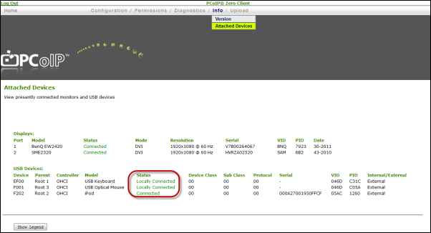
- Non-HID devices are automatically bridged and do not need to be bridged again.
- Bridged HID devices may appear sluggish under sufficient network latency.

