8848

5/1/2014
10ZiG Linux V10 User Guide

About This Guide
Thank you for choosing from the 10ZiG Technology series of thin clients which are specifically designed for power users in an office environment. They feature a powerful, yet simple and affordable solution to virtual desktop computing in a fashionable and sleek design.

In this User Guide, you will find everything you need to quickly begin using your new device. Please be sure to verify with your network administrator that your network is prepared for the configuration of your new device.

Declaration of Conformity
It is hereby declared that this device is in conformity with the essential requirements, and other relevant provisions of the CE and the FCC.

CE Mark Warning
This is a class B device, in a domestic or office environment. This product may cause radio interference, in which case the user may be required to take adequate measures.

Waste Electrical and Electronic Equipment (WEEE) Warning
To potentially avoid adverse effects on the environment, and human health, as a result of the presence of hazardous substances in electrical and electronic equipment, end users of electrical and electronic equipment should understand the meaning of the crossed-out wheeled bin symbol. Do NOT dispose of WEEE as unsorted municipal waste as municipalities must collect WEEE separately.

Table of Contents

Getting Started 1

Packing List 1

Initial Setup 1

Initial Boot-up 1

Support 2

Serial Number 2

Control Panel 3

Introduction 3

Control Panel 3
Applications…………………………………………………………………………………………………….3
Citrix Receiver……………………………………………………………………………………………….3
VMware View Client………………………………………………………………………………………...5
System: 9
Security Settings 9
System Logs 9
System Information 10
General 10
Packages 10
Advanced 10
VNC Settings 11
Time & Date 12
Clock Tab 12
Time Zone Tab 12
Time Server Tab 13
Certificates 13
Hardware: 15
Network Configuration 15
For Wireless enabled Units Only 15
Display 19
Smart Card Service 20
Keyboard 21
Sound 22
USB Devices 22
Mouse 23

Getting Started

Packing List

The following components are included in the package:
- Thin Client Device
- Stand
- 12 VDC Power Adapter with Cord

Optional equipment that may be included:
- USB Wheel Mouse
- USB to PS2 Adapter
- SVGA to DVI Adapter
- Monitor Mount Kit (may include optional video cable)
- SVGA and DVI splitter cable
- Wireless Network Adapter and Antenna
- Quick Installation Guide & Management Software CD

Check this list before installation to ensure that you have received each item ordered. If you are missing any items, please contact technical support.

Initial Setup

To setup the device for initial use：
- Attach the Stand (if desired)
- Connect a Keyboard, Monitor and Mouse
- Connect to a Network and a Power Source

Initial Boot-up
Upon initial boot-up, the unit will attempt to configure the network settings using DHCP. Once the unit has obtained an IP address, you may continue through the remainder of the setup process by filling in the required information based on your preferences and geographical settings. During the setup wizard, you will be asked to fill in your country location, the time zone you are in, and the current date and time.

Support

If you require support for your Linux-based thin client, please contact your region’s nearest Technical Support Center. While 10ZiG Technology does provide technical support for its Linux-based thin clients, it does not provide support for the Linux operating system or application components that are obtained from the open source community and that may be included as part of the software image installed.

10ZiG Technology Limited

Headquarters US

23309 N 17th Dr - Ste 100

Phoenix, AZ 85027

Phone 866-864-5250 • Fax 623-516-8697

support@10zig.com

sales@10zig.com

www.10zig.com

Headquarters UK

10ZiG Technology Limited

Unit S2, Troon Way Business Centre
Humberstone Lane
Leicester
LE4 9HA
UK

Phone +44 (0)116 2148650 • Fax +44 (0)116 2148651

support@10zig.eu

sales@10zig.eu

www.10zig.eu

Serial Number

Each thin client has a unique serial number which is labeled as ID CODE: followed by the MAC address of the unit. The sticker with this information may be found either on the side, bottom or near the video output port, depending on which model you have. Please have this number available when contacting 10ZiG Technology’s Technical Support for assistance. You may also find this number in the 10Zig Manager or while on the unit itself under Control Panel> Network> Local Area> Status… labeled Physical Address.

Introduction

This section provides the user with instructions for the hardware configuration of the Linux-based thin client and explains the various utilities used to accomplish these tasks. Typically, a thin client is configured locally and then used as a template to configure other units. These saved configuration templates may then be pushed out to additional thin clients using the optional 10ZiG Server Manager

Control Panel

Control Panel
The Control Panel is where you will find easy access to all of the settings you wish to configure for the unit. It can be easily accessed by exiting the application that was preloaded onto the unit and selecting the Settings... button.

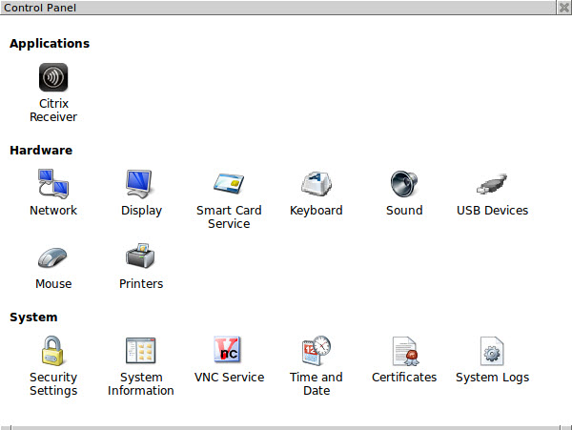

Applications: Citrix Receiver – 8848C
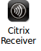
Citrix Receiver General page - 8848C
To configure your Citrix Receiver, click on the “Settings Button”, then double click on the Citrix Receiver icon, when the applet opens, on the general tab in the “Connection type” box, choose between HTTP/HTTPS (XenDesktop/XenApp/VDI-in-a-Box) or Java (Kaviza/VDI-in-a-Box) depending on how your Citrix environment is setup,

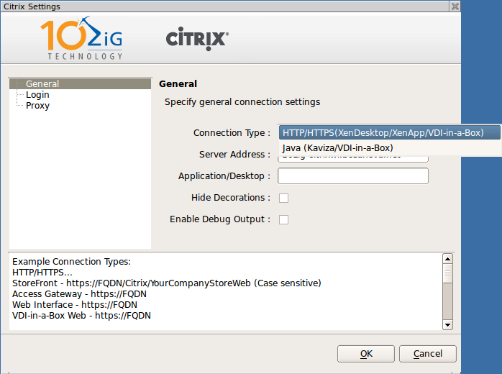
If you’re not sure of which type of connection you have in your environment some connection type examples are also listed for your assistance. Once you have your connection type, fill in the server address box with the fully qualified domain name, you can also choose any applications or desktops that are available to that users credentials. You can also choose to hide decorations and enable debug output from the general page of the Citrix applet.
Citrix Receiver Login page - 8848C
On the login page, you can provide username, password and domain for a specific user or leave these fields blank for general use and users will have to enter their credentials to access the Citrix connection.

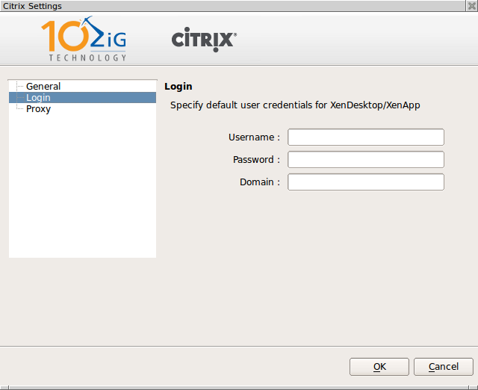

Citrix Receiver Proxy page - 8848C
On the Proxy page, you can enter a proxy server to connect to if used in your environment.
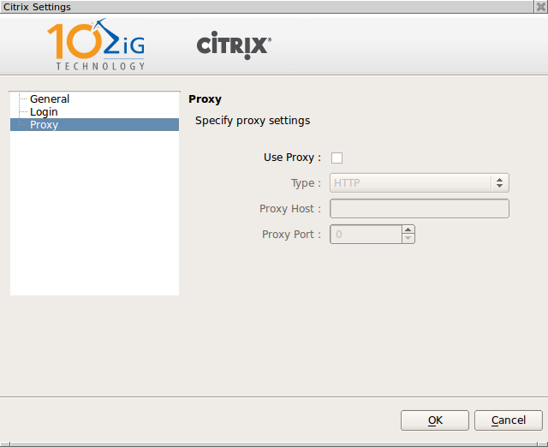
Once you have all of your settings click on the OK button, close the control panel and your Citrix connection is now waiting for login.

Applications: Vmware View client – 8848V
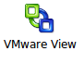
Vmware View client General page
To configure your VMware View Client settings, click on the “Settings Button” and then double click on the VMware View icon. On the general page enter the full qualified domain name of your Vmware server. You can also enter a desktop name, enable reconnect session and set the reconnect timer.

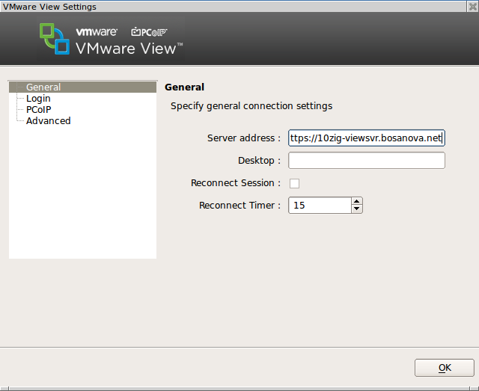

Vmware View client Login page
On the login page, you can provide username, password and domain for a specific user or leave these fields blank for general use and users will have to enter their credentials to access the Vmware connection. You can also set the Kisok mode from this page.

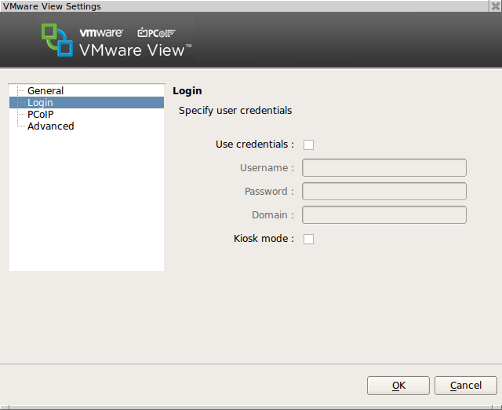

Vmware View client PCoIP page
On the PCoIP page you can change the Image cache size, enable show cache hits and also enable FIPS Mode
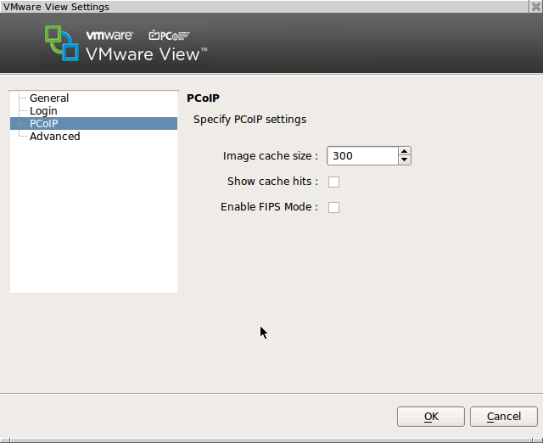

Vmware View client Advanced page
On the Advanced page you can choose your preferred protocol, either PCoIP or RDP. You can choose to enable or disable sound redirection (on by default). You can set the RDP experencience to either, LAN, broadband or modem. You can enable USB log, choose to show users the menu bar, and enable connect once.
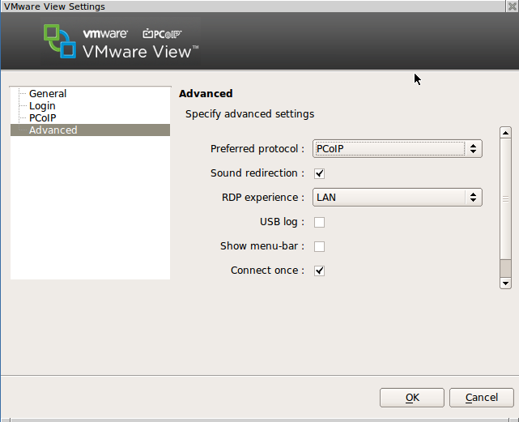
Once you have all of your settings click on the OK button, close the control panel and your Vmware connection is now waiting for login.

System:

Security Settings
The Security Settings allows the user or systems administrator to password protect access to the Control Panel’s various functions and configurations by choosing the Lock down control panel and setting a password. The Enable installation from USB storage allows users or administrator to install an SSL certificate when the check box is selected. Enable SSH client allow user or administrators to connect to the client via SSH when the check box is selected.
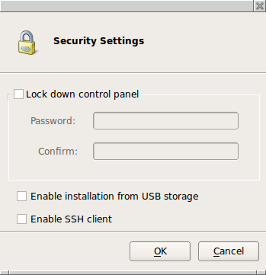

System Logs
Selecting a Log file from the left pane will enable you to view it in the right pane. Please Note:If you are asked by a 10Zig Support technician, you may select the log file and then Click on the Send Log button at the bottom of the window to copy the file automatically to the 10Zig FTP site (a working connection to the Internet is required).

System Information

General
The General screen displays information about the current software version installed as well as information about the Model and Name of the unit. Here you may change the name using the Change Name… button if desired.

Packages
Selecting Packages will show the currently installed Linux packages on the unit.

Advanced
The Advanced screen shows the Hardware and Firmware information as well as providing access to the Console or Factory Default options. Selecting the Factory Default… button will delete all saved parameters and return the unit back to the factory default state. Factory default may also be reset from the unit’s keyboard by pressing SHIFT-CTL-ALT-F or from the 10ZiG Manager utility by right clicking on the unit and selecting Configuration – Reset to Factory Default.

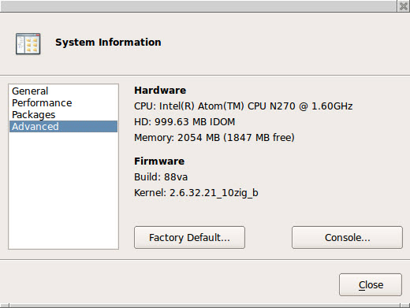

VNC Settings
Here you may edit the settings used to remotely connect to the unit using VNC (Virtual Network Computing). Options include: when the server should start, whether or not to prompt the user for permission to connect to the unit, and the option to password protect any connection from a remote source.

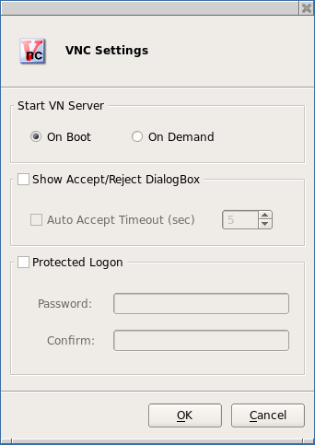

Time & Date
The Time & Date utility allows you to set the date and time, select the appropriate time zone, and enable an NTP (Network Time Protocol) Time Server.

Clock Tab
The Clock tab allows the user to set the current date and time. Please Note: You must Click the Apply button before exiting or all of your changes made here will be lost.
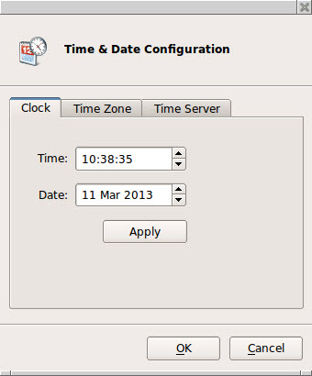

Time Zone Tab
Here you may edit your Time Zone if the one selected during the initial Setup Wizard is no longer correct.
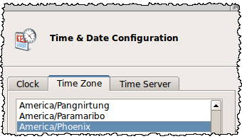

Time Server Tab
Here you may select the Use time server checkbox and enter a valid NTP Server address if you would like the unit to automatically update the Date & Time.

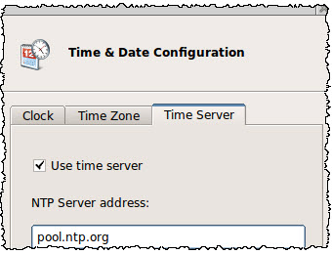

Certificates
The Certificates window allows you to view Imported and Base certificates installed on the unit.

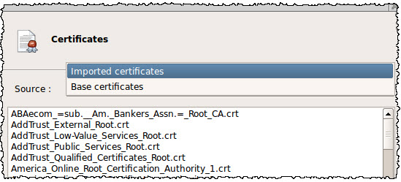

To view a certificate, select it from the list and then Click on the Show button.
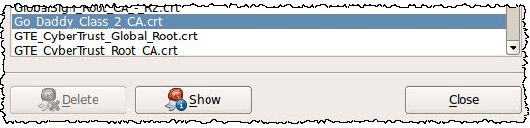
To import a certificate, Enter the Control panel by pressing the settings button, then double click on the Security Settings icon, now check the box to “Enable installation from USB storage” and then click the OK button.
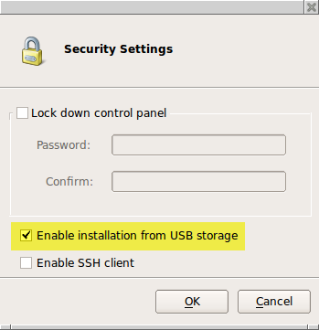
Now you can insert a USB drive (Formatted to FAT32) into the unit that contains a .crt or .pem file in the root directory. This will automatically open the USB Installer window. Here you may select the certificate(s) you would like to import into the unit. When finished, you will need to reboot the unit to view the newly imported certificate(s).
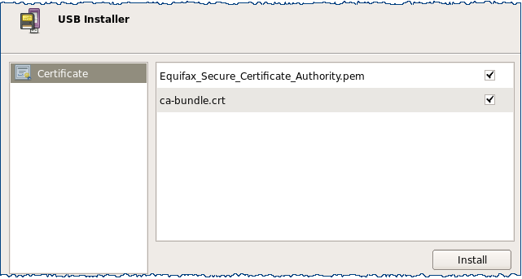

Hardware:
Network Configuration
Here you will find options to configure your network settings. If only one type of connection is available, it will be automatically set to Default.
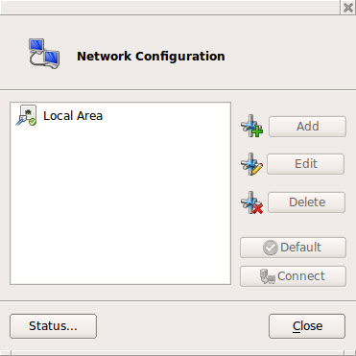

For Wireless enabled Units Only:
If the unit is enabled with a 10Zig Wireless network interface, the Add button will become selectable and you may then continue to configure your Wireless connection.
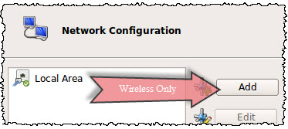

For Wireless enabled Units Only(Cont.):
Clicking the Refresh button will force the unit to scan for any available broadcasted wireless networks and to display the results in the SSID: drop down menu. Selecting an SSID from the drop down will display its current Signal Strength
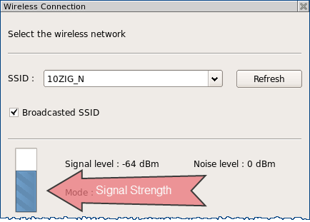

After selecting the Wireless Network to connect to and clicking OK, the Network Settings Window for the connection will open. Here you may select your Security Mode from the drop down menu and then enter your Passphrase if required. Additionally, you may edit your TCP/IP Properties and Hosts for this connection from the Tabs here as well.
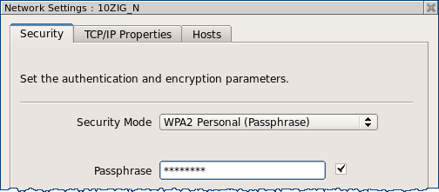

From the Network Configuration window:
Highlighting a connection and then clicking the Edit button will display additional network settings for the selected connection.
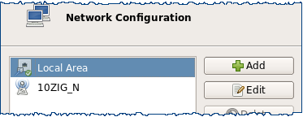
Selecting the TCP/IP Properties tab for the connection will allow you to manually configure your IP settings with a Static IP Address.
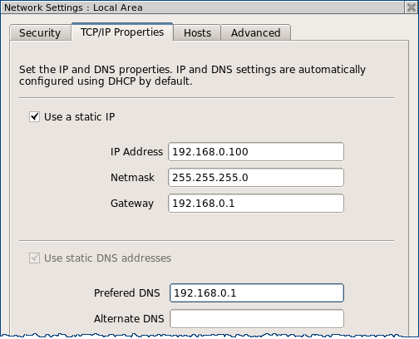

From the Network Configuration window:
Selecting the Status button will display your current network connection status.
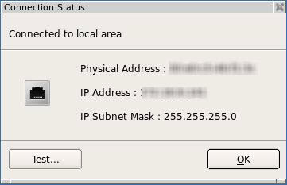

Selecting the Test... button opens the Connection Test window where you may chose a destination to ping to.
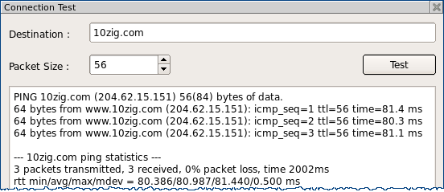

Display
The Display Settings window allows you to configure your screen resolution along with the refresh rate and the color quality. Other options here include rotation and support for multiple displays, if detected.
NOTE: When multiple displays are detected, you will be given the option to select Make this my main display and Extend these displays under Multiple displays. To detect or reset detection, click on the Detect button.

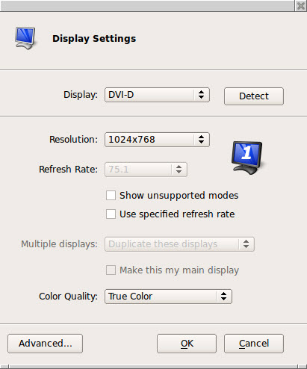

Clicking the Advanced… button will open the window with options to enable Power Saving-DPMS settings. Here you may configure the timers for each desired instance.
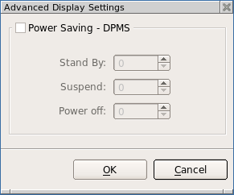

Smart Card Service
The Smart Card Service window allows you to enable Smart Card detection and Refresh detection of any connected Smart Cards. Any devices found will be displayed in the Dialog box.
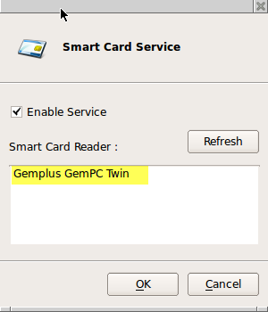

Keyboard
Opening the Keyboard window displays the Layout Tab which allows you to select the keyboard model and country layout, as well as test keystroke output in the Test Keyboard: dialog box.
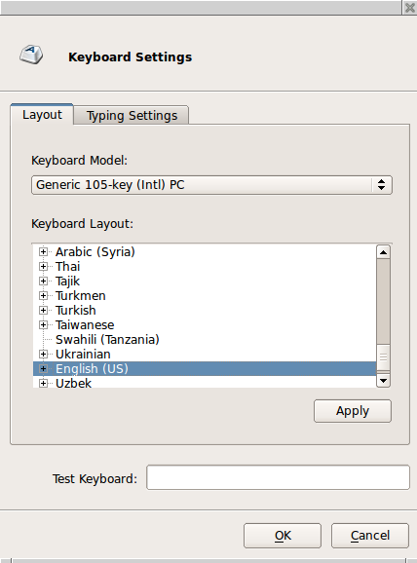
The keyboard character repeat parameters, and the enable Numlock at startup checkbox are located under the Typing Settings Tab.

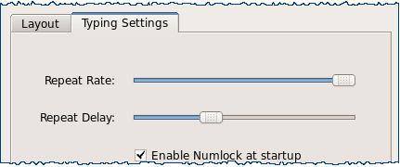

Sound
The Sound window allows you to control the speaker (Output:) and microphone (Input:) volumes, and tells what Audio device is being used.
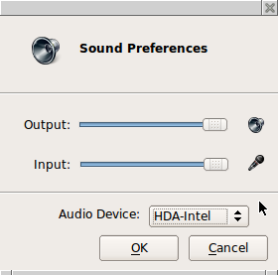

USB Devices
USB Device Redirection for VMware and Citrix ICA may be controlled here. Options are Default, Include or Exclude. NOTE: USB Redirection in VMware View Client (only on 8848v) - when a USB printer or USB storage device is connected to the thin client, the VM (Virtual Machine) will immediately recognize the USB device and indicate that new hardware has been found. For printers, the printer driver must be installed on the VM in order for it to work correctly.
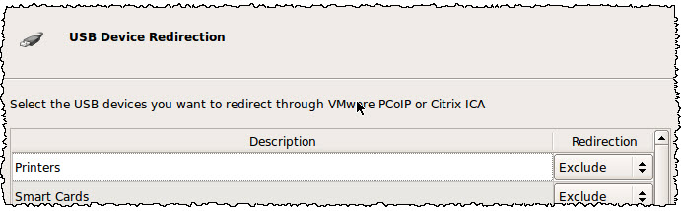

Mouse
Currently only USB and PS2 mice are supported. The Type option is automatically detected at system boot with no ability to change it. The Mouse window allows you to set the mouse speed, and acceleration settings. You may also configure the mouse buttons for 3 button emulation or for left-handed users.

